Pick and Place Project 2016

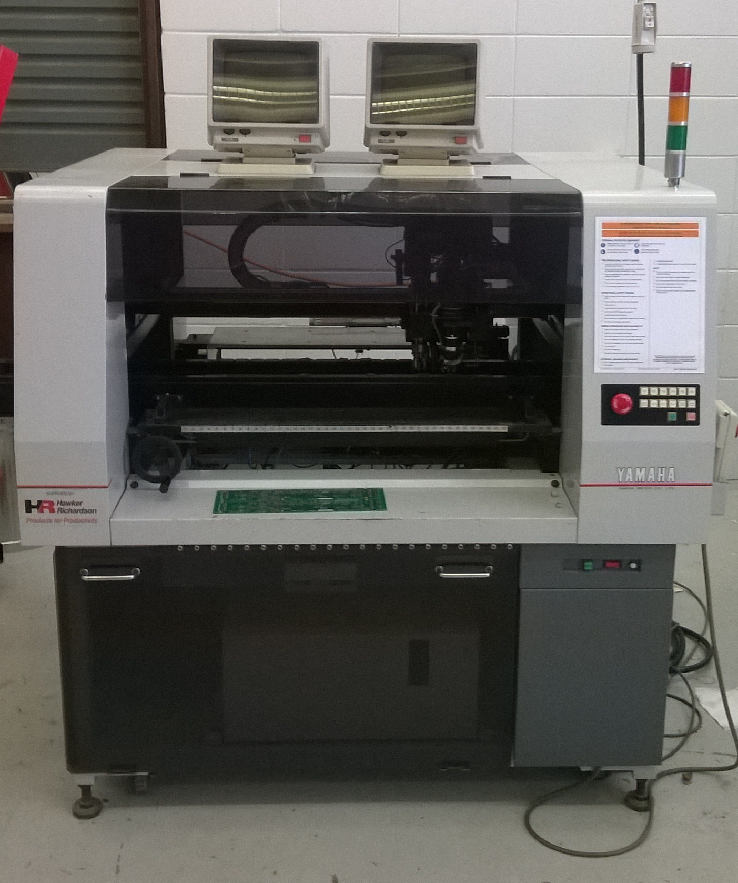

Pick and place project 2016

Identify project

Pricing and Procurement

Identify problems

Circuit diagram

PCB design

Software design

Build prototype

Conclusion

Identify Project

Pricing and Procurement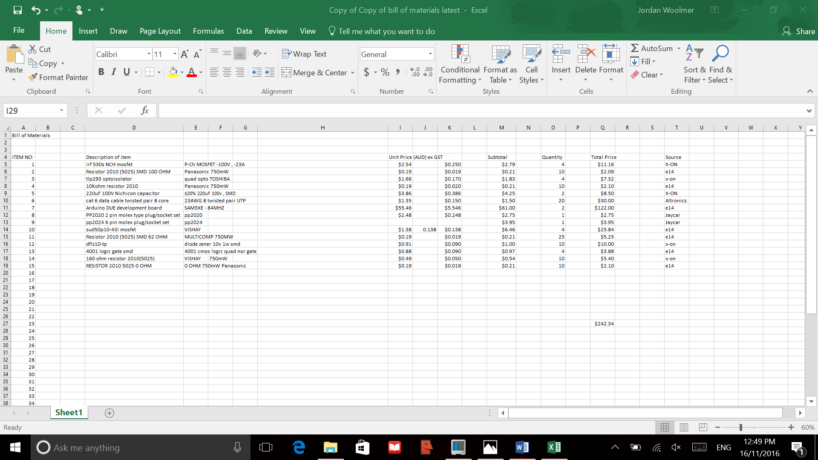

The pricing and sourcing was all through either X-ON , element14, Jaycar , and Altronics. Majority is sourced from X-ON and element14. This is because they were cheaper sources considering the fact that we could not use eBay , and they had the specific surface mount components that we required . The rest was from either Jaycar or Altronics, as they were connectors or cable that was cheaper and easier to buy locally as it was more expensive on element14/X-ON. The most expensive part was the Arduino DUE , at AUD$61 for each board. But the benefit of this is that these are the original Arduino boards , so they have the correct components with the correct bootloader , for easier programming . It is also easier to find documentation for the original , as it is more developed , and has had more revisions than other boards , as it was created first . The Arduino DUE has CANbus compatibility , which makes it ideal for our project , as well as quadrature compatibility , which is the type of encoding that the motor uses . The MOSFETS are intentionally 10 Amps at 100v , so there is plenty of overhead space for excess current and higher voltage , especially when the motor starts initially . The network protocol that we are using is RS485 , which is one of many protocols used in industry. It is a two wire system , and CAT6 cable makes for an ideal transmission medium . Inside the cable there are 4 pairs of wire , so in reality , 80 metres of twin conductor twisted pair will be available . This is more than enough , as all of the wiring will be within the pick and place machine .

Identify Problems

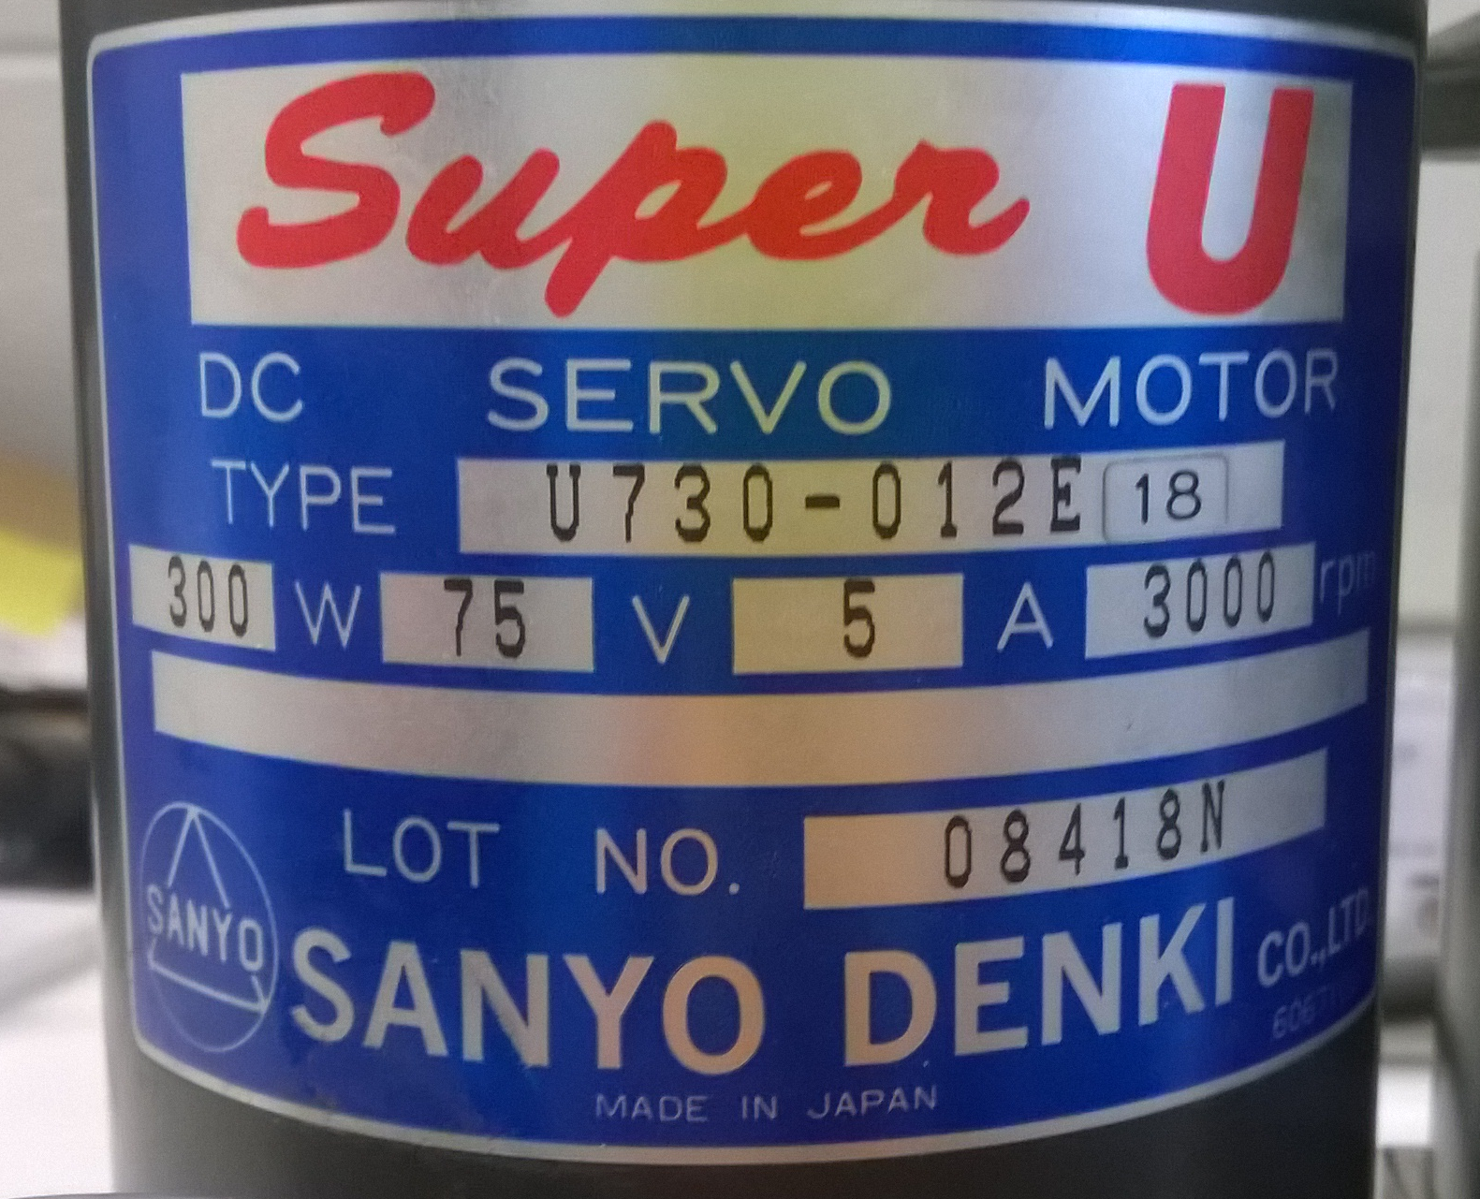

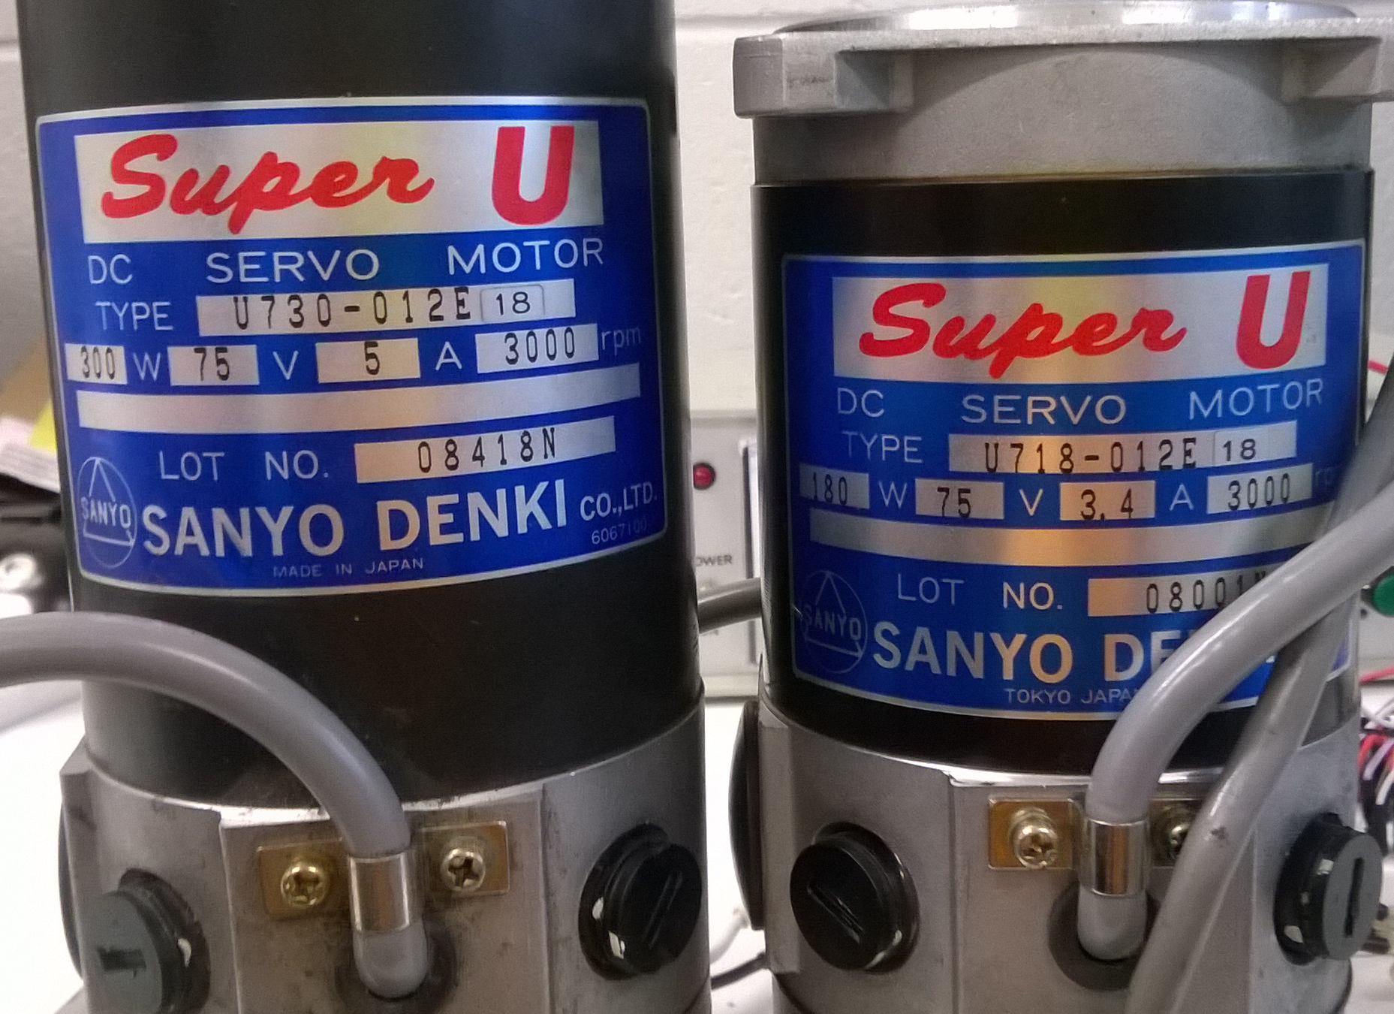

Software Design

Prototype design

